Case 2-A181-ME-Judea Pillar Figurine-Open Skull-Iron Age II-1000-550 BCE

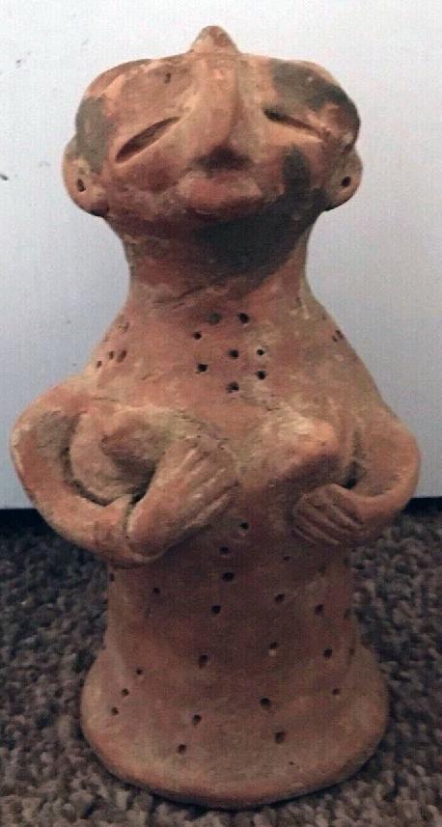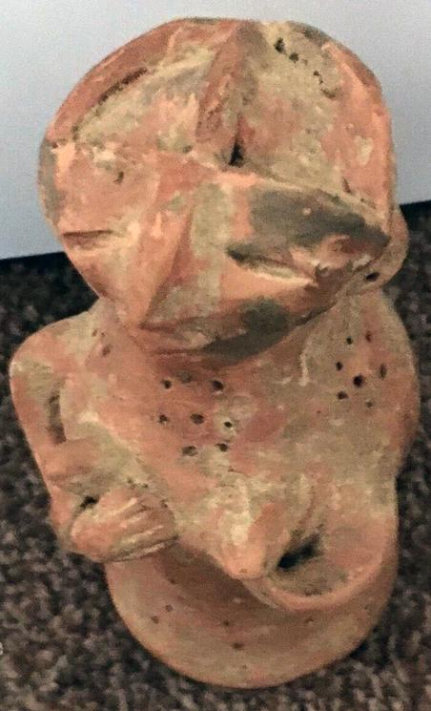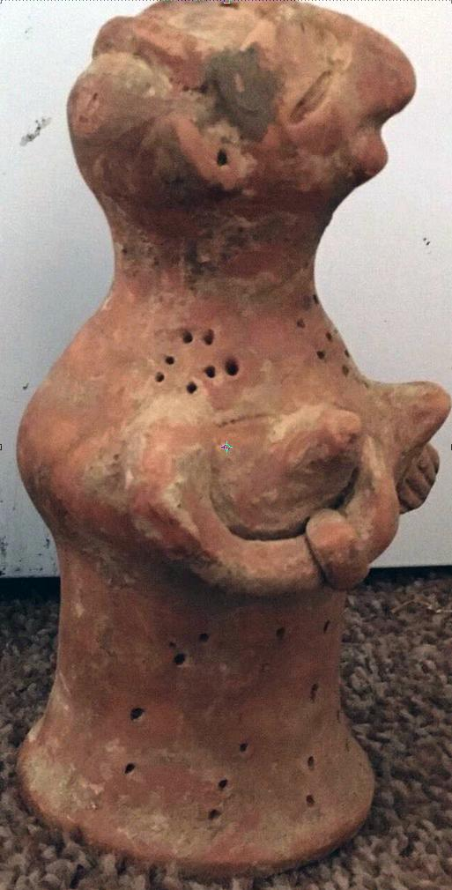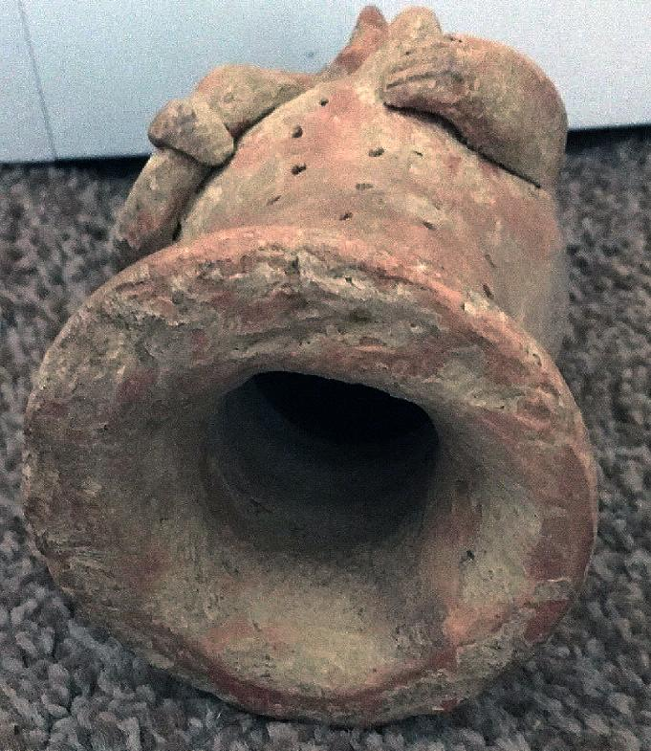

**Case No.: 2**

**Accession Number: A181**

**Formal Label:** ME-Judea Pillar Figurine-Open Skull-Iron Age II-1000-550 BCE

**Display Description: After Greener 2018.**

Thousands of terra-cotta figurines dating to the Iron Age II (First Temple Period) have been found at  archaeological sites located in the biblical Kingdom of Judah, including Jerusalem.

The figurines fall into two main categories:

**Human Figurines –**Female Judahite Pillar Figurines (JPF’s) form the vast majority among anthropomorphic figurines. These stand ca. 6 inches tall (with either pinched or less common mold-made heads) and are often clutching their breasts. Male figurines, other than the horse riders (below) were rare in Judah.

**Animal Figurines –**The more abundant group are the zoomorphic (or animal) figurines; most of these are horses, some with riders on their backs.

Figurines were popular among Judah’s neighboring nations as well (such as the Israelites, Philistines, and Phoenicians). The figurines in each region, including Judah, had some unique stylistic motifs and attributes, though cross-cultural influences were also common. Since all the figurines were individually manufactured (the only part made in a mold were some of the heads), each is unique in form and size, although the common figurines are very schematic and stereotyped. They seem to have been common mostly in domestic contexts, i.e., in people’s homes. Their production and use seem to have stopped after the Babylonian conquest and destruction of the Kingdom of Judah in 586 BCE.

In all excavations in biblical Judah the quantity of the zoomorphic figurines is greater than that of the anthropomorphic ones, nevertheless, the latter have traditionally received more attention. Their identity and function are the focus of ongoing debates in archaeology and biblical studies.

**Interpretations of the Figurines’ Identity, Function and Symbolism**. Since textual sources that relate directly to the issue of household cultic practices in the Iron Age Levant are rare, and direct mention of terra cotta figurines remains ambiguous (see below), the study of this sphere must rely heavily on the archaeological record. The figurines are almost always found broken and discovered in secondary contexts—in refuse or fill contexts (i.e., not in their original place of use).  They contain no distinguishing marks – of individual, mortal, divine identity, age, or status – which might assist in identification and interpretation. For these reasons, their interpretation is debated.

Numerous scholars have offered their thoughts on these figurines. The typical questions raised in the discussions have largely centered on who the figurines might have represented and how they might have been used: Are they depictions of a female deity such as Astarte or Asherah? Do they depict a human female? Were they used as votives, fertility charms, toys for children, or even something else?

**Identity.** In the 1930s, prominent scholar William Foxwell Albright identified the female figurines with the Canaanite goddess Astarte (Hebrew ʻAštōreṯ). She was a foreign, non-Judahite goddess of fertility, sexuality, and war adopted from the Phoenicians. This identification remained popular for several decades.

More recently, however, scholars have turned their attention to Asherah (probably perceived as YHWH’s consort in biblical times), given her prominent position within the Yahwistic cult. The distribution of an inexpensive icon that incorporates Asherah’s trademark tree image seems plausible.

Yet another group of scholars believe that the figurines do not represent a specific goddess, but rather mortal women (in a generic form) which were used as votive figurines, presented to the gods or goddesses.

**Function and Symbolism.** Many different theories have been suggested over the years regarding the function and symbolism of JPFs.

**Fertility –**Some scholars have related them to female domestic ritual practices bestowing plenty and fertility on the household.

**Apotropaic** – Other scholars have suggested that figurines may have carried an apotropaic or healing function, posting that they were addressed in prayers or wishes during times of need.

**Amulets** – Yet others suggested that they served as amulets for domestic use, namely as talismans or good luck charms.

Biblical legislation would allow these uses, which do not include worship or any of the specified forms of forbidden magic. No biblical texts prohibit apotropaic or prophylactic rites, nor do they prohibit therapeutic rituals.

**Domestic cult** – Others prefer to interpret the JPF’s, alongside the zoomorphic and Horse-and-Rider figurines, as popular representations related to either the official state religion, or to forbidden female, foreign, or even pagan cults. In other words, JPF’s may personify an amalgamated goddess or (ancestral) intercessors through which one appealed for divine favors. Similarly, some have suggested that the animal figurines and the Horse-and-riders may have been used together in the domestic cult to represent Asherah and her entourage.

The biblical text prohibits several types of images. For example, the Decalogue (Ten Commandments) prohibits the people of Israel from making a *pesel*(Deut 5:7-8):

|  |  |
| --- | --- |
| לֹא תַעֲשֶׂה לְךָ פֶסֶל כָּל תְּמוּנָה אֲשֶׁר בַּשָּׁמַיִם מִמַּעַל וַאֲשֶׁר בָּאָרֶץ מִתָּחַת וַאֲשֶׁר בַּמַּיִם מִתַּחַת לָאָרֶץ. ח לֹא תִשְׁתַּחֲוֶה לָהֶם וְלֹא תָעָבְדֵם | You shall not make for yourselves a sculptured image (*pesel*), any likeness of what is in the heavens above, or on the earth below, or in the waters below the earth. You shall not bow down to them or serve them….” |

Deut. 4:16-18 likely elaborates upon this prohibition:

|  |  |
| --- | --- |
| פֶּן תַּשְׁחִתוּן וַעֲשִׂיתֶם לָכֶם פֶּסֶל תְּמוּנַת כָּל סָמֶל תַּבְנִית זָכָר אוֹ נְקֵבָה. תַּבְנִית כָּל בְּהֵמָה אֲשֶׁר בָּאָרֶץ תַּבְנִית כָּל צִפּוֹר כָּנָף אֲשֶׁר תָּעוּף בַּשָּׁמָיִם. תַּבְנִית כָּל רֹמֵשׂ בָּאֲדָמָה תַּבְנִית כָּל דָּגָה אֲשֶׁר בַּמַּיִם מִתַּחַת לָאָרֶץ. | Do not act wickedly and make for yourselves a sculptured image (*pesel*) in any likeness whatever (*semel* *tabnît):* the form of a man or a woman, the form (*tabnît)*of any beast on earth, the form (*tabnît)*of any winged bird that flies in the sky, the form (*tabnît)*of anything that creeps on the ground, the form of any fish that is in the waters below the earth.” |

Similarly, the Israelites are prohibited from worshipping certain pre-existent items, even if they did not manufacture them. This is noted especially in Deut 7:5, which commands to “tear down their [the Canaanites] altars, *smash their pillars*, cut down their sacred posts, and consign their images (*pesileihem*) to fire.”

**Idol Production: A Focus on Materials.** In an attempt to identify which biblical term/s (if any) may refer to the JPF’s, Erin Darby has recently summarized some of the scholarship on this topic (Darby 2014). The Hebrew word *pesel* is the most common biblical term for an idol. Its related verb means, “to hew” or “hew into shape,” and can refer to stone tables or building stones (e.g. Exod 34:1, 4; Deut 10:1, 3; 1 Kgs 5:22). The noun, however, refers to idols in general. These seem to have usually been made of wood, stone, or metal (e.g. Isa 30:12; Deut. 7:5), and this is the likely referent in the early use of the term *pesel*, though the term may theoretically refer to a wider range of materials, including clay.

**LC Classification:**

**Date or Time Horizon:**

**Geographical Area:**

**Map:**

**GPS Coordinates:**

**Cultural Affiliation:**

**Medium:**

**Dimensions:** H 20 cm x Dia 9 cm

**Weight: 587g, 1 lb 4.5 oz**

**Condition: original**

**Provenance:** part of an old collection

**Condition:**

**Discussion:**

Iron II (1000-550) witnessed the rise of the states of Judah and Israel in the tenth-ninth century. These small principalities exercise considerable control over their particular regions due in part to the decline of the great powers, Assyria and Egypt, from about 1200 to 900. Beginning in the eighth century and certainly in the seventh century, Assyria reestablishes its authority over the eastern Mediterranean area and exercises almost complete control. The northern state of Israel is obliterated in 722/721 by King Sargon and its inhabitants taken into exile. Judah, left alone, gradually accommodates to Assyrian control, but towards the end of the seventh century it does revolt as the Assyrian empire disintegrated. Judah's freedom was short-lived, however, and eventually snuffed out by the Chaldean kings who conquered Jerusalem and took some of the ruling class into exile to Babylon. During the period of exile in Babylon, the area, particularly from Jerusalem south, shows a mark decline. Other areas just north of Jerusalem are almost unaffected by the catastrophe that befell Judah. From https://www.bu.edu/anep/Ir.html

**References:**

Aharoni, Y. "New Aspects of the Israelite Occupation in the North." Near Eastern Archaeology in the Twentieth Century, Essays in Honor of Nelson Glueck. New York, 1970.

Darby, Erin . 2014. Interpreting Judean Pillar Figurines: Gender and Empire in Judean Apotropaic Ritual Mohr Siebeck.

Dever, William G. 2005. Did God Have a Wife?: Archaeology and Folk religion in Ancient Israel. Eerdmans

Finkelstein, Israel. The Archaeology of the Israelite Settlement. Jerusalem, 1988.

Greener, Aaron. 2018. What Are Clay Female Figurines Doing in Judah during the Biblical Period? <https://thetorah.com/what-are-clay-female-figurines-doing-in-judah-during-the-biblical-period/>

Kletter, Raz . 1996. The Judean Pillar-Figurines and the Archaeology of Asherah. Oxford.

Weippert, Manfred. The Settlement of the Israelite Tribes in Palestine. Illinois, 1971.